**Chef-Infra-server – Master Node**

**Connection chef-client to chef-server using HTTPS**

**Connection chef-server to chef-workstation using SSH**

* **sudo -i**
* **passwd root (given as test)**
* **vi /etc/ssh/sshd_config**

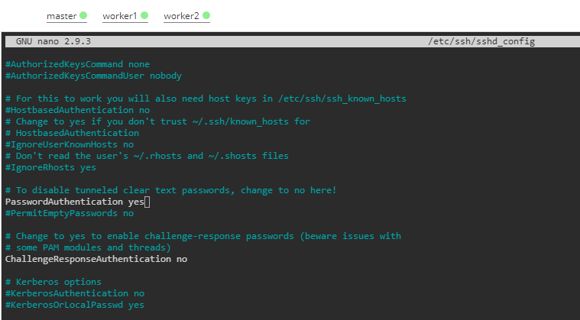

* **Update this file with details**

PermitRootLogin yes

PasswordAuthentication yes

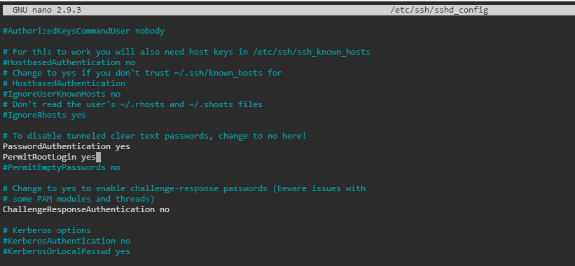

* **systemctl restart sshd**
* **systemctl status sshd**

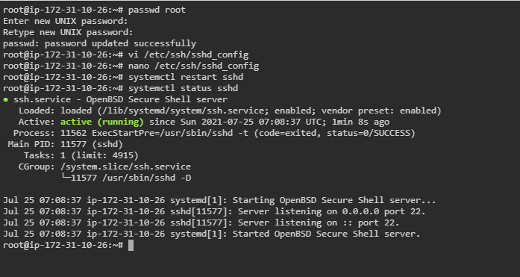

* **wget** [**https://packages.chef.io/files/stable/chef-server/14.0.65/ubuntu/18.04/chef-server-core_14.0.65-1_amd64.deb**](https://packages.chef.io/files/stable/chef-server/14.0.65/ubuntu/18.04/chef-server-core_14.0.65-1_amd64.deb)

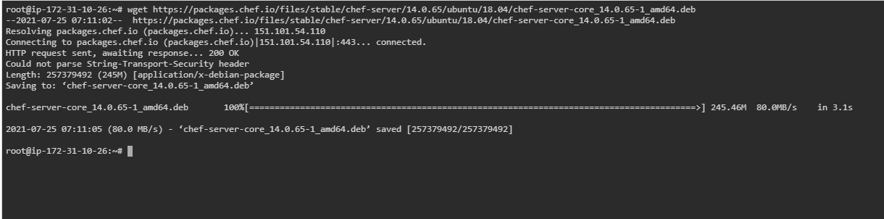

* **dpkg -i chef-server-core_14.0.65-1_amd64.deb**

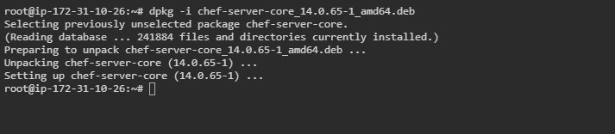

* **chef-server-ctl –help**
* **chef-server-ctl reconfigure**

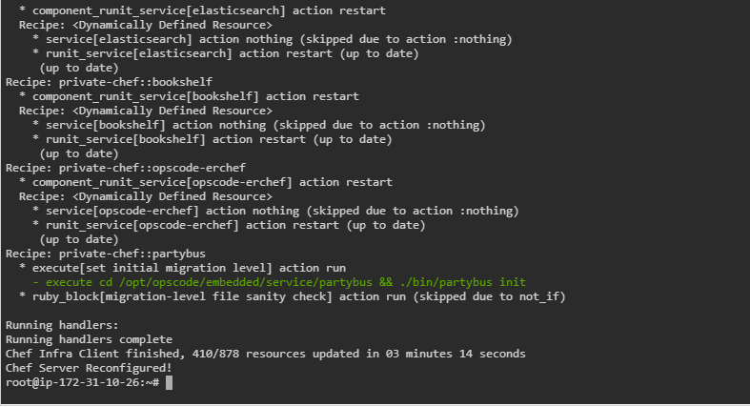

* **chef-server-ctl status**

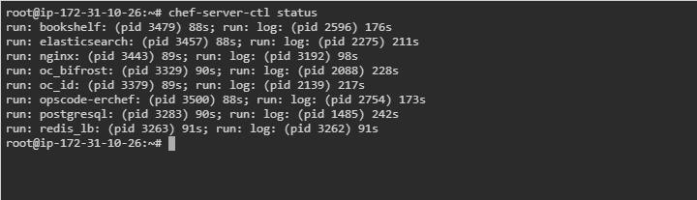

* **chef-server-ctl install chef-manage**

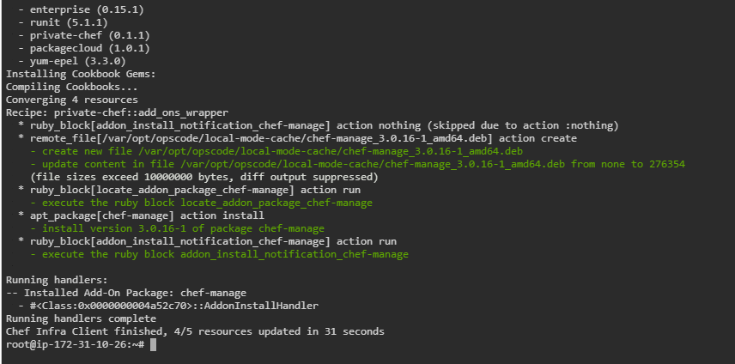

* **chef-server-ctl status**

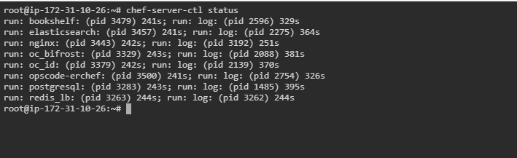

* **opscode-manage-ctl --help**
* opscode-manage-ctl reconfigure

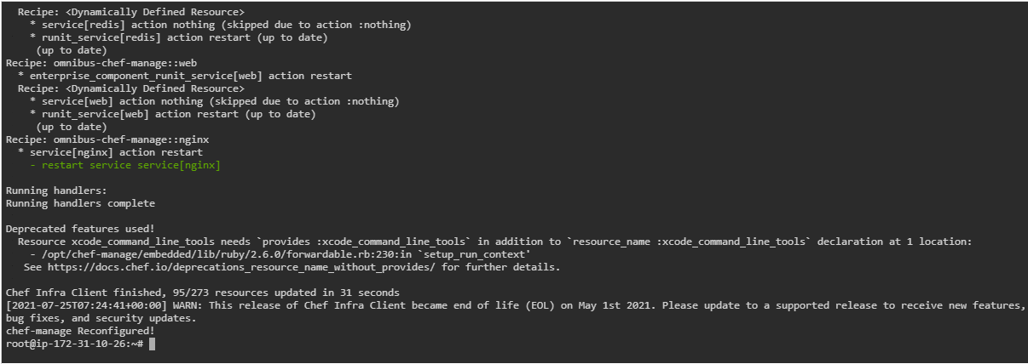

* **chef-server-ctl status**

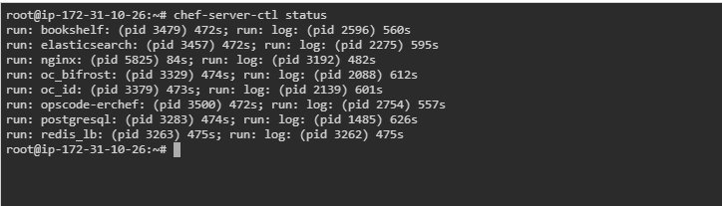

**Note: Don't Forget to use** [**https://localhost**](https://localhost)

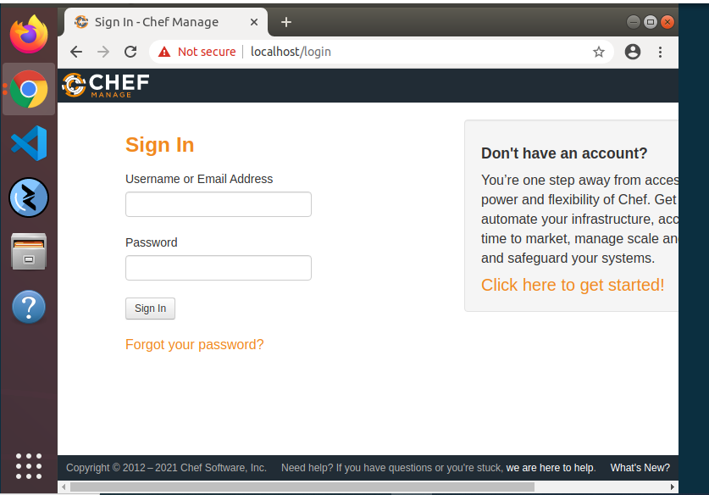

* **chef-server-ctl --help**
* **chef-server-ctl user-create –help**

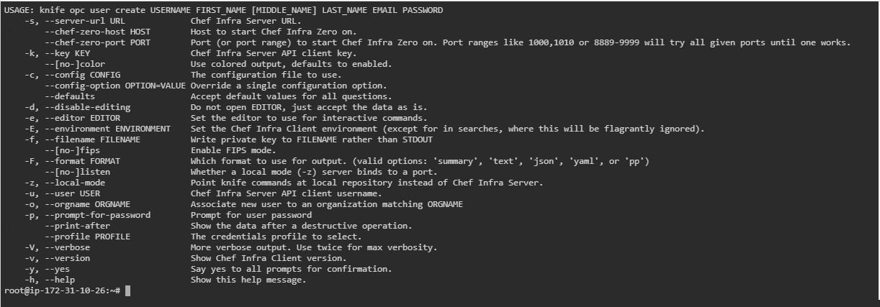

* **chef-server-ctl user-create admin Bipin Singh bipin@simplilearn.com redhat --filename /etc/chef/admin.pem**

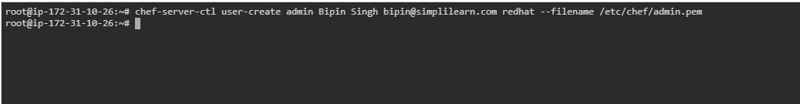

* **chef-server-ctl –help**
* **chef-server-ctl org-create –help**
* **chef-server-ctl org-create simplilearn "SimpliLearn INC" --association_user admin --filename /etc/chef/simplilearn.pem**

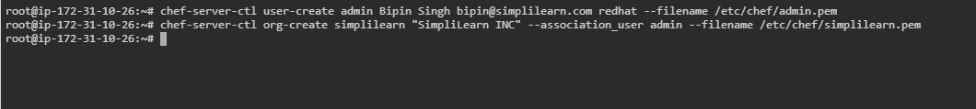

**Chef-workstation-server setup - (Worker Node-01)**

* **Sudo -i**
* **passwd root (has been set as test)**

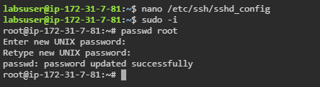

* **vi /etc/ssh/sshd_config**

**PermitRootLogin yes**

**PasswordAuthentication yes**

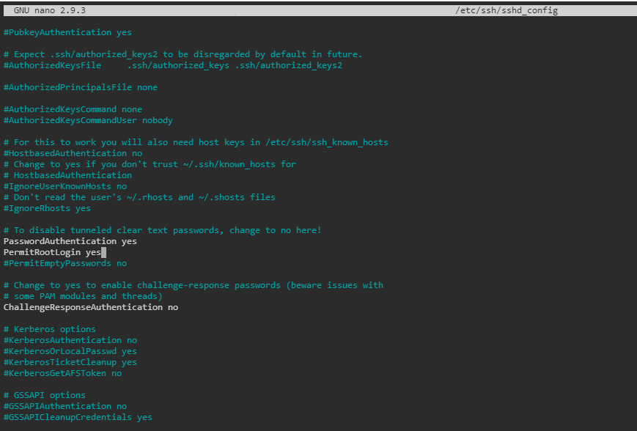

* **systemctl restart sshd**
* **wget** [**https://packages.chef.io/files/stable/chef-workstation/21.2.278/ubuntu/20.04/chef-workstation_21.2.278-1_amd64.deb**](https://packages.chef.io/files/stable/chef-workstation/21.2.278/ubuntu/20.04/chef-workstation_21.2.278-1_amd64.deb)

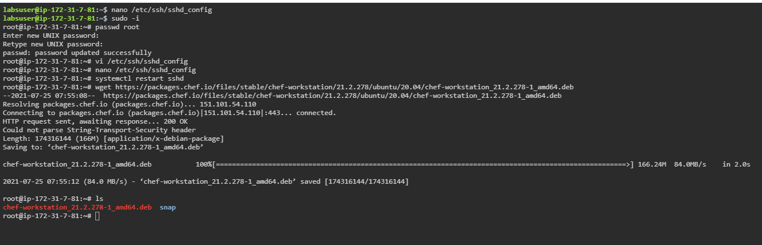

* **dpkg -i chef-workstation_21.2.278-1_amd64.deb**

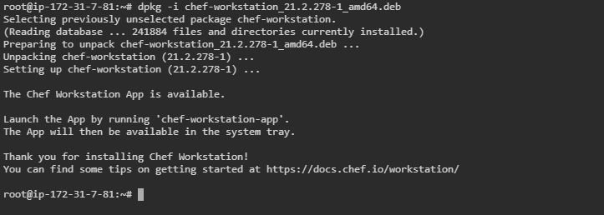

* **chef generate repo chef-repo**

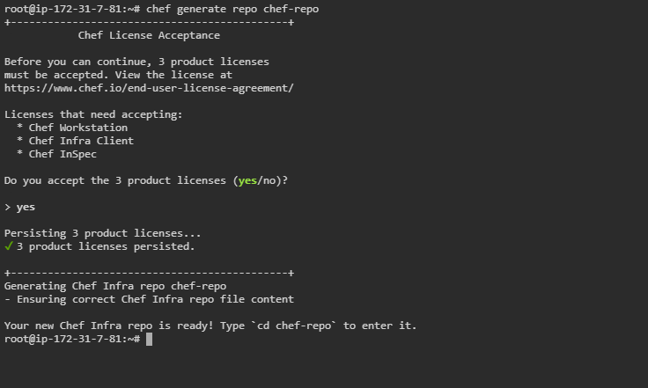

* **chef generate repo chef-repo**
* **cd chef-repo/**
* **git config --global user.name admin**
* **git config --global user.email test@test.com**
* **echo '.chef' >> .gitignore**
* **mkdir .chef**
* **git add .**
* **git commit -m "test"**
* **hostname -i**
* **cd .chef/**

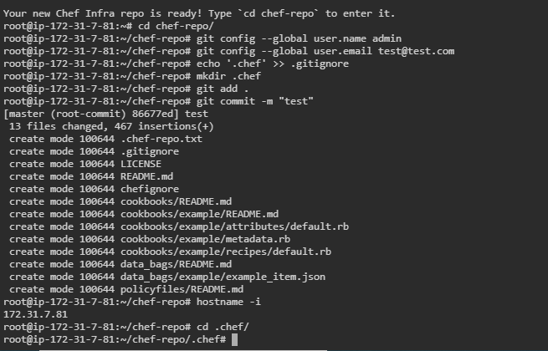

**We need to copy admin.pem and simplilearn.pem which we created on the chef-infra server to the workstation to establish connection (chef-Infra to chef-workstation)**



**Get Hostname IP of workstation using cmd hostname -i**

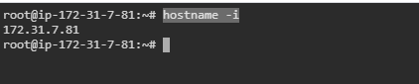

* **From the master node (Chef-infra-Server) copy the two files to the chef-workstation-node using scp cmd**
* **cd /etc/chef/**

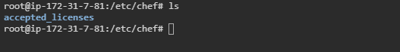

**worker Node-01 host name: 172.31.7.81**

* **scp admin.pem root@172.31.7.81://root/chef-repo/.chef/**
* **scp simplilearn.pem** [**root@172.31.7.81://root/chef-repo/.chef/**](mailto:root@172.31.7.81://root/chef-repo/.chef/)

**During copy it will ask the root user password for workstation not for infra-server, provided test**

**DONT FORGET TO CHANGE THE IP WITH YOU WORKSTATION IP IN THE ABOVE COMMANDS**

**Get Info from chef-infra-node (master)**

* **hostname -f**

**ip-172-31-10-26.us-west-2.compute.internal**

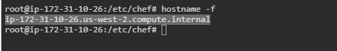

**On Worker Node-01**

* **cd /root/chef-repo/.chef**
* **nano knife.rb**

current_dir = File.dirname(__FILE__)

log_level                :info

log_location             STDOUT

node_name                "admin"

client_key               "#{current_dir}/admin.pem"

#validation_client_name  "simplilearn"

chef_server_url          "https://server/organizations/simplilearn"

syntax_check_cache_path "#{ENV['HOME']}/.chef/syntaxcache"

cookbook_path            ["#{current_dir}/../cookbooks"]

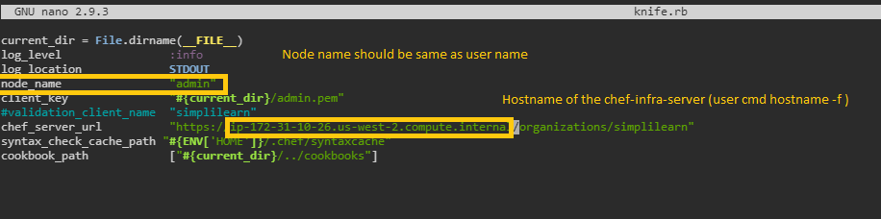

* **knife ssl fetch**

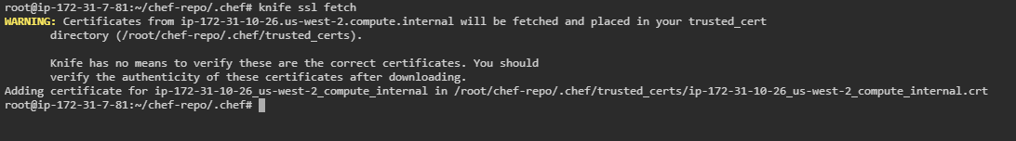

* **knife ssl check**

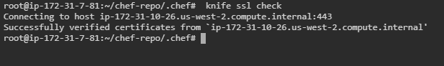

* **knife node list**

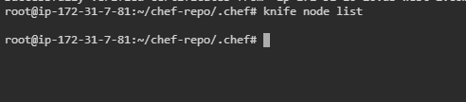

**Bootstrap Chef-client from Chef-Workstation**

**Execute the below commands o the client server to be added to chef-workstation ad chef-infra-server**

* **sudo -i**
* **passwd root (given password as test)**

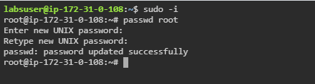

* **nano /etc/ssh/sshd_config**

PermitRootLogin yes

PasswordAuthentication yes

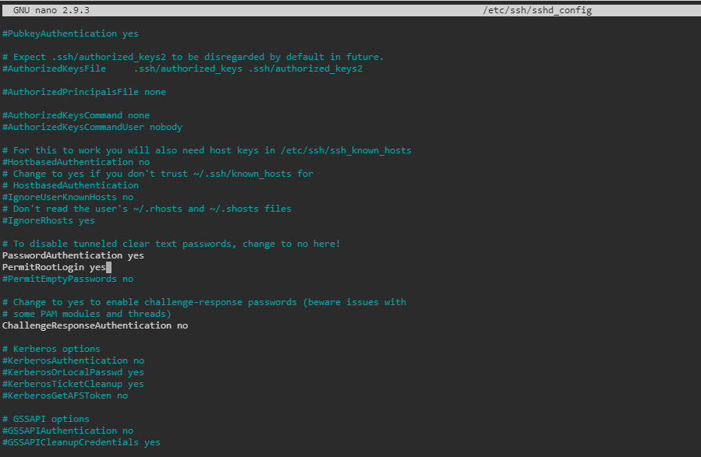

* **systemctl restart sshd**
* **hostname -i**

**172.31.0.108**

* **hostname -f**

**ip-172-31-0-108.us-west-2.compute.internal**

**GO TO THE WORKSTATION CHEF SERVER NODE (Worker Node-01)**

* **knife bootstrap <CLINET_SERVER_HOST_NAME> --ssh-user root --ssh-password=test --node-name client1**

**e.g knife bootstrap ip-172-31-0-108.us-west-2.compute.internal --ssh-user root --ssh-password=test --node-name client1**

**Node name can be given any name.**

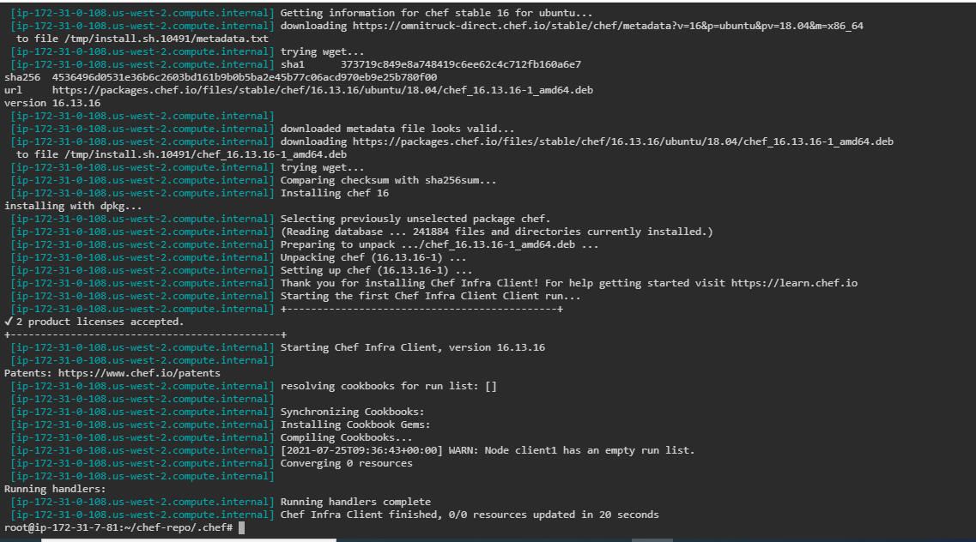

* **knife node list**

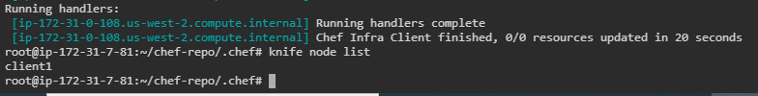

**\*\*\* CONGRATULATIONS CHEF-CLIENT SERVER IS BOOTSTRAPED SUCESSFULLY ON THE CHEF-WORKSTATION-SERVER \*\*\***